384 Sq Ft Customizable Small House
$24,900 watertight shell or $64,900 finished (does not include well, septic, foundation or land)
16x24 with half loft bedroom(12x16)
6x12 Bathroom, 10x12 Kitchen/Dining Room, 12x24 Living Room
12’ walls in living room with vaulted ceiling, 8’ walls in kitchen/bath, 4’-7’ walls in loft
Standard 2x6 construction, R19 Insulation in Walls and R30 in Ceiling
Includes 2 doors and 10 windows, vinyl siding, architectural shingles, shiplap interior walls
Estimated time to build onsite - 4 weeks for watertight shell and additional 4 weeks to finish
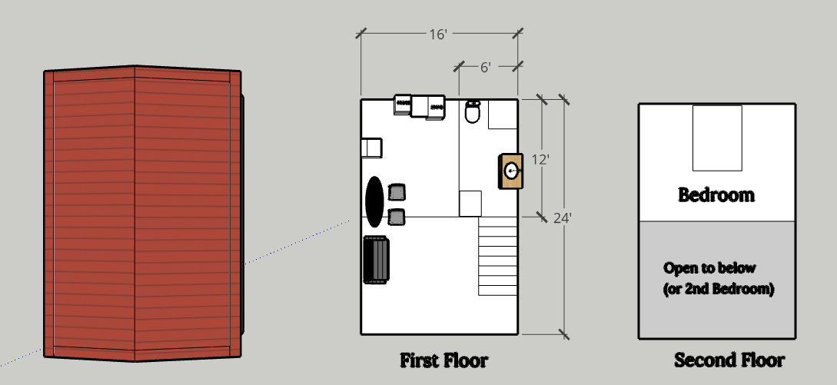
Drawing above is a basic sample layout.
Options:
Metal Roof – Add $2k
2nd Loft Bedroom – Add $1,500 for watertight shell and another $1,500 to finish
Additional Estimated Costs Not Included:
Site clearing/prep - $2k-$10k
Septic - $15k-$25k
Well - $5k-$10k
Land - $50k-$200k
Foundation - $8k-$15k

